**– Penamaan Variabel –**

TextBox :

* txt_hostname
* txt_ipadress
* txt_data

Button :

* btn_getpage
* btn_checkip

**– Codingan btn_getpage –**

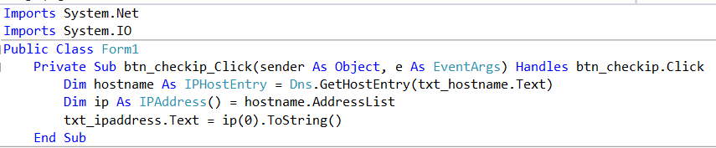

**– Codingan btn_checkip –**

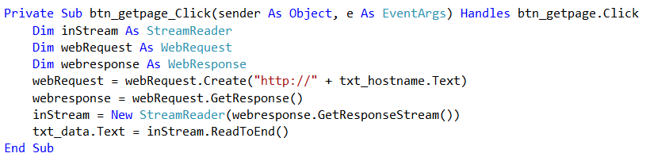

**– Screenshot –**

* Codingan Button
* Output